**Bahria University, Lahore Campus**

Department of Computer Science

Lab Journal 01

**(Spring 2023)**

|  |  |  |
| --- | --- | --- |
| Course: | **Data Structures and Algorithm - Lab** | Date: _2-4-2023___ |
| Course Code: | CSL-221 | Max Marks: 10 |
| Faculty’s Name: | Fatima Zulfiqar |  |

Name: AFFAN AHMAD_ Enroll No: _03-134221-003____ Class: _BS(CS)3A__

Objective(s):

Upon completion of this lab session, learners will be able to:

* Declare and initialize array data structure.
* Perform different operations on arrays (Insertion, deletion, search, display)

## Lab Tasks:

**Task 1**

Write a program to define an integer type array of fixed size and store elements by taking input from the user. Also print values present in an array.

#include<iostream>

using namespace std;

void ar()

{

int arr[0];

int size =10;

cout << "enter elements in an array :"<< endl;

for(int i=0;i<size;i++)

{

cout <<"arr["<<i<<"]=";cin>>arr[i];

}

cout << "your array elements are :"<< endl;

for(int i=0;i<size;i++)

{

cout <<"arr["<<i<<"]="<< arr[i]<<endl;

}

}

int main ()

{

ar();

return 0;

}

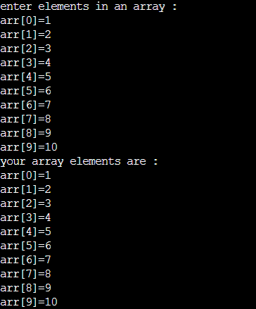

**Task 2**

Write a program in a form of different functions and a main menu. Perform following operations on an array.

* Deletion by index
* Deletion by value
* Search by index
* Search by Value

#include<iostream>

using namespace std;

int arr[0];

int size =5;

int *ptr=new int;

int z=0,c=0;

int *p1=new int;

int *p2=new int;

void insert()

{

cout << "enter elements in an array :"<< endl;

for(int i=0;i<size;i++)

{

cout <<"arr["<<i<<"]=";cin>>ptr[i];

}

}

void search_by_value()

{

int index,val,a=0;

cout <<"enter your value that you want to search :";cin>>val;

for (int i=0;i<size;i++)

{

if (ptr[i]==val )

{

index=i;

a++;

}

}

if(a>0)

{

cout <<"your value "<<val<<" is found on "<< index+1<< " position "<< endl;

}

else

{

cout <<"your value is not found :"<< endl;

}

}

void search_by_index()

{

int in;

cout <<"enter your index :";cin>>in;

if(in>=size)

{

cout <<"your value is not present in this index :"<< endl;

}

else

{

cout <<"your value present on "<<in<<" index is "<< ptr[in]<< endl;

}

}

void delval()

{

int v1,k1,k2=0;

int n,a1=0;

cout <<endl<<"enter the value :";cin>>v1;

for ( int i=0;i<size;i++)

{

if (ptr[i]==v1 )

{

n=i;

a1++;

}

}

if(a1>0)

{

cout <<"your array is :"<< endl;

for(int i=0;i<n;i++)

{

cout <<ptr[i]<<" ";

}

for(int i=n+1;i<size;i++)

{

k2++;

cout <<ptr[i]<<" ";

}

cout << endl;

}

else

{

cout <<"value is not found "<< endl;

}

}

void del()

{

int pos,k1=0,k2=0;

int a[0],b[0];

cout <<endl<<"enter the index :";cin>>pos;

if (pos>size)

{

cout <<"your index is not present "<< endl;

}

else

{

for(int i=0;i<size;i++)

{

if (i<pos)

{

p1[z++]=ptr[i];

}

else

{

p2[c++]=ptr[i];

}

}

z=z-1;

cout <<"your array is :"<< endl;

for (int i=0;i<z+c;i++)

{

if (i<z)

{

ptr[i]=p1[i];

}

else

{

ptr[i]=p2[k1++];

}

}

cout << endl;

for(int i=0;i<c+z;i++)

{

cout << ptr[i]<<" ";

}

size=c+z;

cout << endl;

}

}

int main ()

{

int ch;

cout <<"press 1 for insert in array :"<< endl;

cout <<"press 2 for search by value :"<< endl;

cout <<"press 3 for search by index :"<< endl;

cout <<"press 4 for delete_by_value :"<< endl;

cout <<"press 5 for delete_by_index :"<< endl;

cout <<"press 6 for Exit :"<< endl;

do{

cout <<"Enter your choise :";cin>>ch;

if (ch==1)

{

insert();

}

if (ch==2)

{

search_by_value();

}

if (ch==3)

{

search_by_index();

}

if (ch==4)

{

delval();

}

if (ch==5)

{

del();

}

if (ch==6)

{

cout <<"Exit"<< endl;

break;

}

}while(ch!=6);

return 0;

}

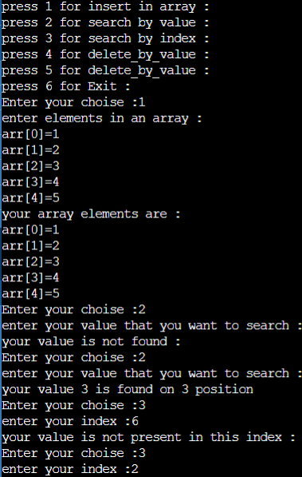

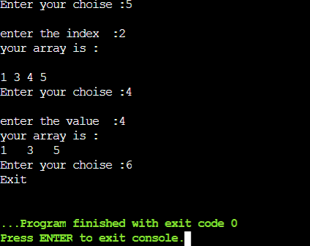

**Lab Grading Sheet:**

|  |  |  |  |
| --- | --- | --- | --- |
| **Task** | **Max Marks** | **Obtained Marks** | **Comments(*if any*)** |
| 1. | 02 |  |  |
| 2. | 08 |  |  |
| **Total** | **10** |  | **Signature** |

**Note : Attempt all tasks and get them checked by your Lab Instructor.**